**INSTAPOLL**

Index

* Product Documentation
* Process Documentation
* Technical Documentation
  1. Api Documentation
  2. Data Model Documentation
  3. Architecture Documentation
  4. User Guide
  5. Release Notes
  6. Readme
* System Documentation
* User Documentation

**Product Documentation**

**Introduction:**

As we know, the reach of the internet increases day by day in india. It helps to grow and ease the work of the public. As events like public meetings,parties, formal meetings etc grow exponentially. As we know, public engagement is very important in almost every meeting. InstaPoll is a web-application that increases the engagement of the public in the events by use of a rating system and at the same time it increases the security of the public opinion and it increases the transparency of the system which increases the public engagement towards the events. It helps the host of the event to conduct the successful event.

The use of web-application are as follows:-

1. **Real-time Polling:** Instant rating applications allow for real-time rating on different topics, such as surveys, opinions, or preferences. This can be useful in gathering feedback, conducting market research, or making quick decisions based on the majority's opinion.

1. **Live Events and Conferences:** In conferences, seminars, or live events, instant rating applications enable audience engagement and interaction. Attendees can rate on speakers or session topics on the content in real-time, enhancing the overall event experience.

1. **Decision-making Processes:** Instant rating applications facilitate decision-making processes by providing a quick and efficient way to gather rates .This can be useful in various scenarios, such as team meetings, board meetings, or committee discussions, where timely decisions need to be made based on collective input.

1. **Audience Interaction in Presentations:** Instant rating applications enable presenters to interact with their audience during presentations or workshops. They can pose questions, gather opinions, or conduct quizzes, making the session more engaging and interactive.

1. **TV Shows and Entertainment:** Instant rating applications are commonly used in TV shows or entertainment programs where viewers can participate by rating for their favorite contestants, predicting outcomes, or influencing show elements such as game outcomes or storylines.

1. **Market Research and Surveys:** Instant rating applications provide a convenient way to conduct market research and gather survey data. Companies can create surveys, collect responses in real-time, and analyze the results quickly, enabling timely decision-making based on customer feedback.

**Process Documentation**

There are different page in web-application are as follow

1. Login
2. Ragister
3. Dashboard
4. CreatEvent
5. Add-Participants
6. ViewRating
7. Rating

**LoginPage:-** This is the login page in this web-application.It authenticates the user and has the option to go to the register page to create a new user.

**RagisterPage:-** This is a register page which allow to people to create their own login id and password for login and use other function of the application

**Dashboard:-** This is dashboard page which show the user name and total number of event which is created by user and allow to access other page through this page

**CreatEvents:-**This is CreatEvent page which allow user to create event that user wants for poll

**Add-Participants:-**This is an add-participants page which allows the user to add participants especially for that event which is going to be rated by the public or people related to a particular event.

**View-Rating:-** This is view-rating page which offer the user to see the rating of participants of that event which given by public or people related to the event

**Rating:-** This is a Rating page which is open for all the public for rating the participant of the event.This page can only be accessed through a link which is provided by the users.

**Step to use the application**

There are following step involve to use this web-application are as follows :-

Register- login- dashboard- event- creatEvent-  Add Participants- CreatLink-  Give Active Hours- View Rating(User enter the events page and click the view button to see the rating)

**FrontPage:-**

* These is a login page for further use of web-application u have to register the user.
* In this page there is email and password which is entered by the user at time of registrater.
* When the email and password are given successfully then the user able to access the each features of the application

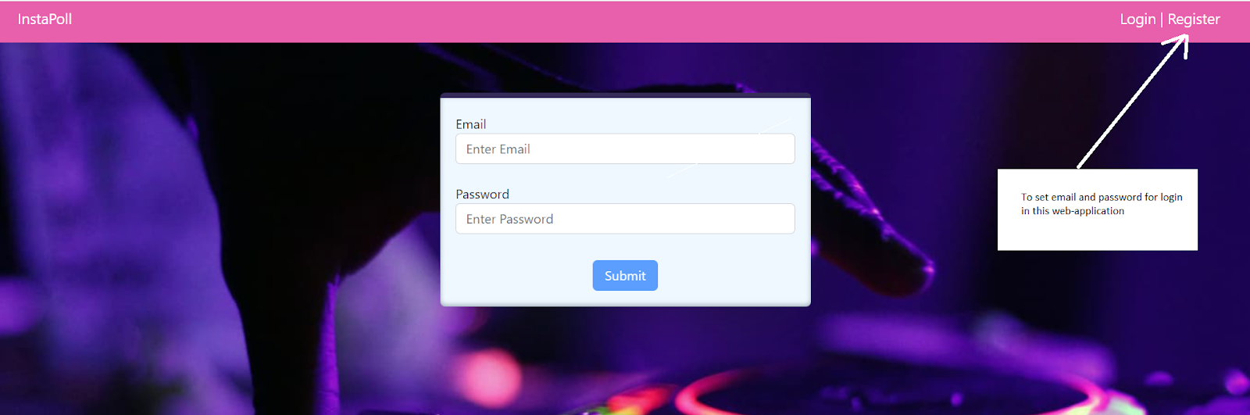

**Dashboard:-**

This is the dashboard page. It allows the user to know the total number of events that have been created. It also shows the name of the user.

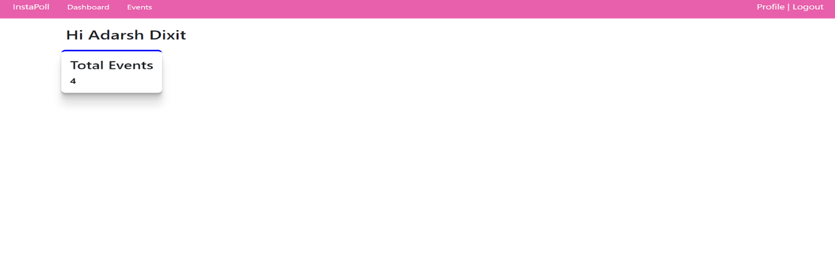

**Events:-**

This is an Event page which has the button CreatEvent ,ViewRating, Add Participant, Create Link. It also shows the detail of each event which is created by the user. It show the Name,Place,Date,Time related to events.

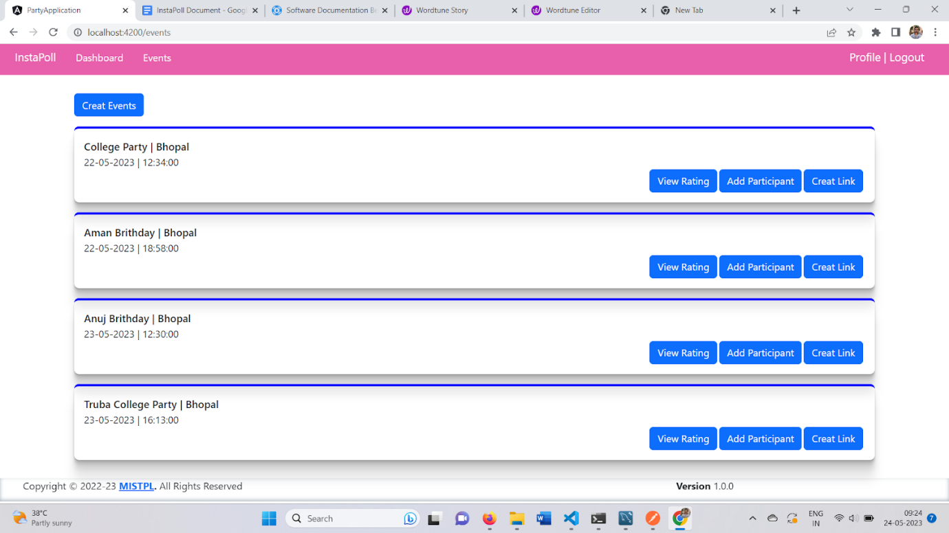

**CreatEvent:-**

This is a page in which users can add an event as their requirement. It is automatically updated in the Events Page.

**View Rating:-**

This is a view rating page as the name suggests as the page works. It shows the rating of participants rating in descending order of rating and top 3 participant table color is green this feature help the user to easily recognize the top rated participant relate to that particular event

**Add Participants:-**

This is an add participants page which allows the user to see the name of participants which is related to the event or we can say that was previously added by the user. It also has the feature to add participants in the event, that participant shows below down to the input box and the participant name is arranged in alphabetical order.

**Create Link:-**

As the name suggests the page works.It shows the created unique link and allows the user to update active hour or we can say that time when the link expires . The link which is created is unique for each and every event that is created. The link is redirected to the event rating page which allows the public to give rating to the participants.This link can be shared to any one by any mode or platform.As we know after a events or in between a event time rating is done but after particular amount of time rating is irrelevant and make no sense so it better to deactivate the  link after a some time so this application allow the user to select amount of time he want to give a public for rating so that it can done efficiently

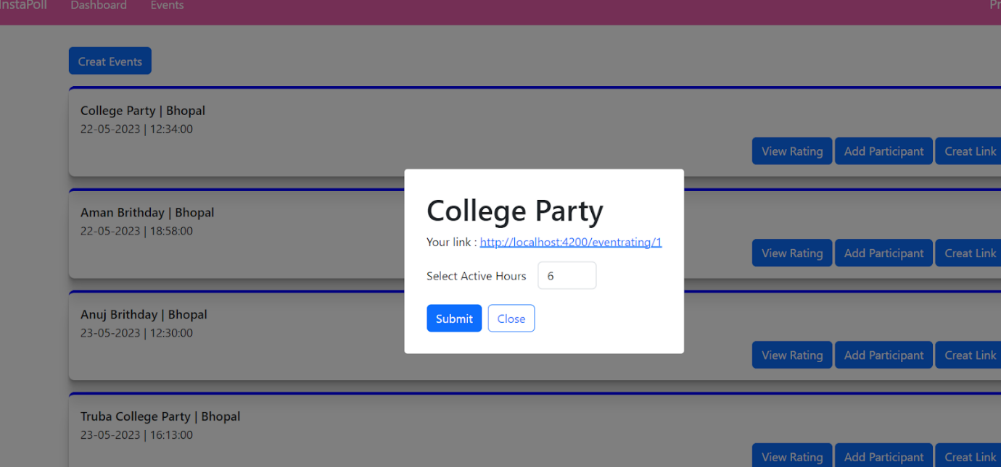

**EventRating:-**

 It shows the name of participants which are added by the users for a particular event and 5 stars also show next to each participant which allow the public to give the rating.

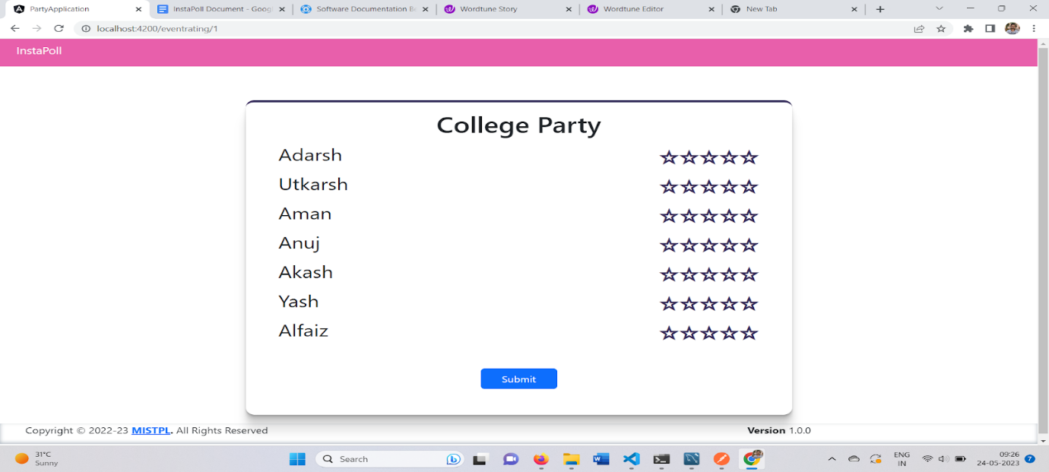

**Api Documentation**

**Introduction**

Welcome to the API documentation for InstaPoll. This document provides details on how to interact with the API, including available endpoints, request/response formats, authentication, and examples.

**Base URL**

The base URL for accessing the API is:  <http://localhost:4112/>

**EndPoint**

Postman: <https://www.postman.com/downloads/>

**System Documentation**

**System Requirements**

To install and run the software system based on Node.js, Angular, and MySQL, ensure that your environment meets the following requirements:

**Software Requirements**

* Operating System: Windows 11
* Node.js: Version 18.12.1 or higher
* Angular: Version 15 or higher
* MySQL Server: Version 8.0 or later

**Dependencies**

The software system relies on the following dependencies:

* **Node.js Packages:**
  + Bcrypt: Version 5.1.0
  + Body-parser: Version 1.20.2
  + Cors: Version 2.8.5
  + Dotenv: Version 16.0.3
  + Express-validator: Version 6.14.2
  + Express: Version 4.18.1
  + Jsonwebtoken: Version 8.5.1
  + Multer: Version 1.4.5-lts.1
  + Mysql2: Version2.3.3
  + Nodemon: Version 2.0.20
  + Sequelize: Version 6.24.0
  + Socket.io: Version 4.5.3
  + Other relevant packages for your specific application

**Network Requirements**

* The system may require outgoing access to the internet for external API integrations or updates.
* Ensure that the necessary network ports are open for communication with the MySQL server.

Please make sure your environment meets these requirements before proceeding with the installation and configuration of the software system**.**